# MODULE 07 Linux and Mac Forensics Screenshots

Lara Alofi

2110886

Y

Computer Hacking Forensic Investigator (CHFI)

Lab Session Identifiers

1. <https://labclient.labondemand.com/LabClient/13784160-86e6-48b1-9d8b-39c5a2fd0a8f>

Username on EC-Council System

1. 2110886@uj.edu.sa

Lab 01

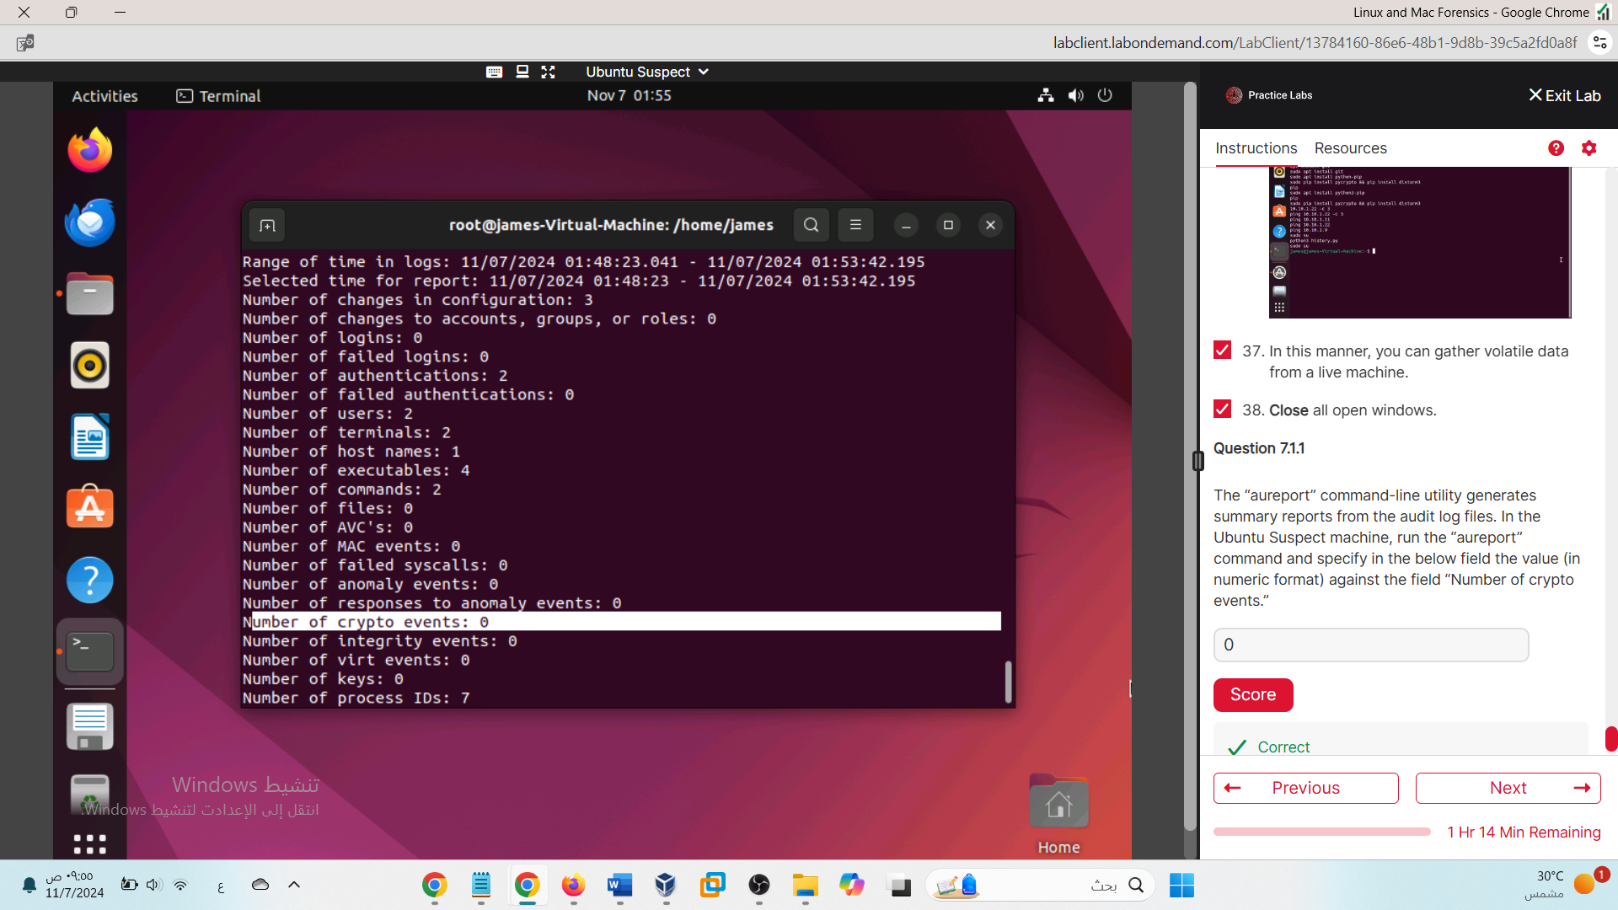

0

Lab 02

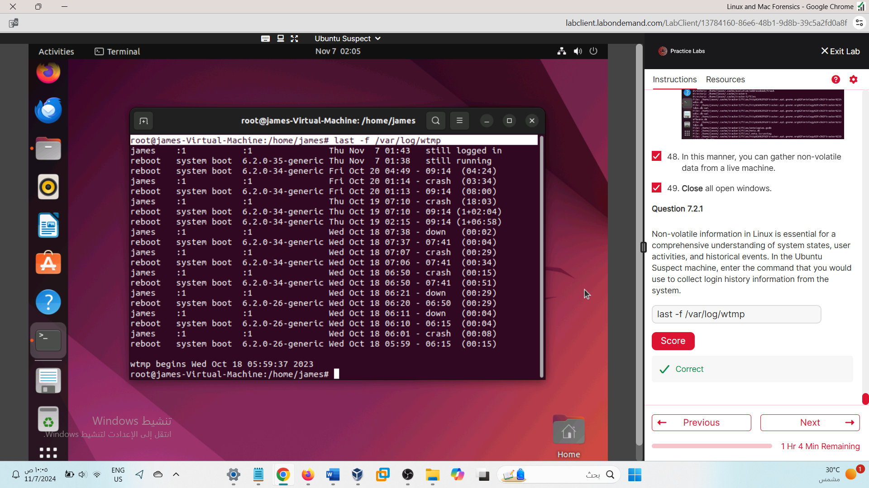

last -f /var/log/wtmp

Lab 03

c2460ce1b6c33da7af5e4d0043cfd22a

Lab 04

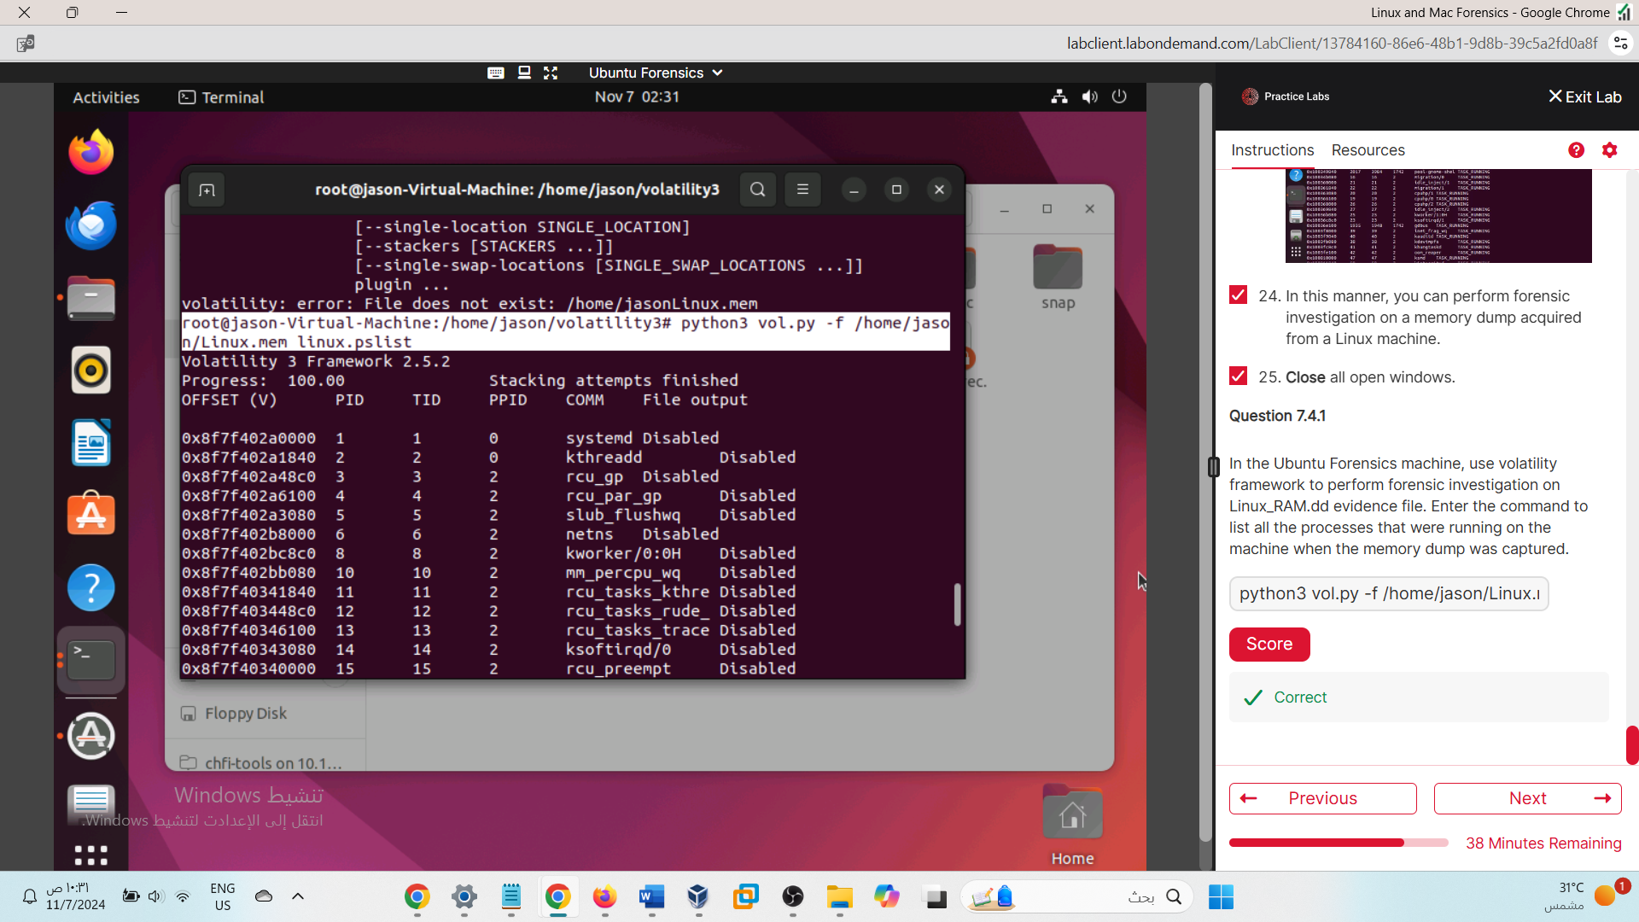

Lab 05



